Thank you for purchasing my work!

To build you scenery use the ‘tile set’ parts (folder: Plataform Game Tileset 2_The Factory\PNG\tiles)

To build your background just pick one color version ( folder: Plataform Game Tileset 2_The Factory\PNG\background) and add the files on your editor in this order:

1) first layer (the one on the back of all the layers ) :

2)this one on layer 2 (use always as reference the bottom of the file to put it on the scene):

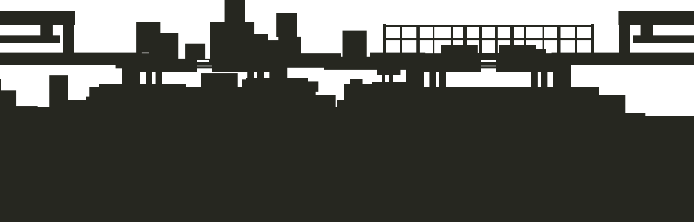

3)And finally this one for layer 3:

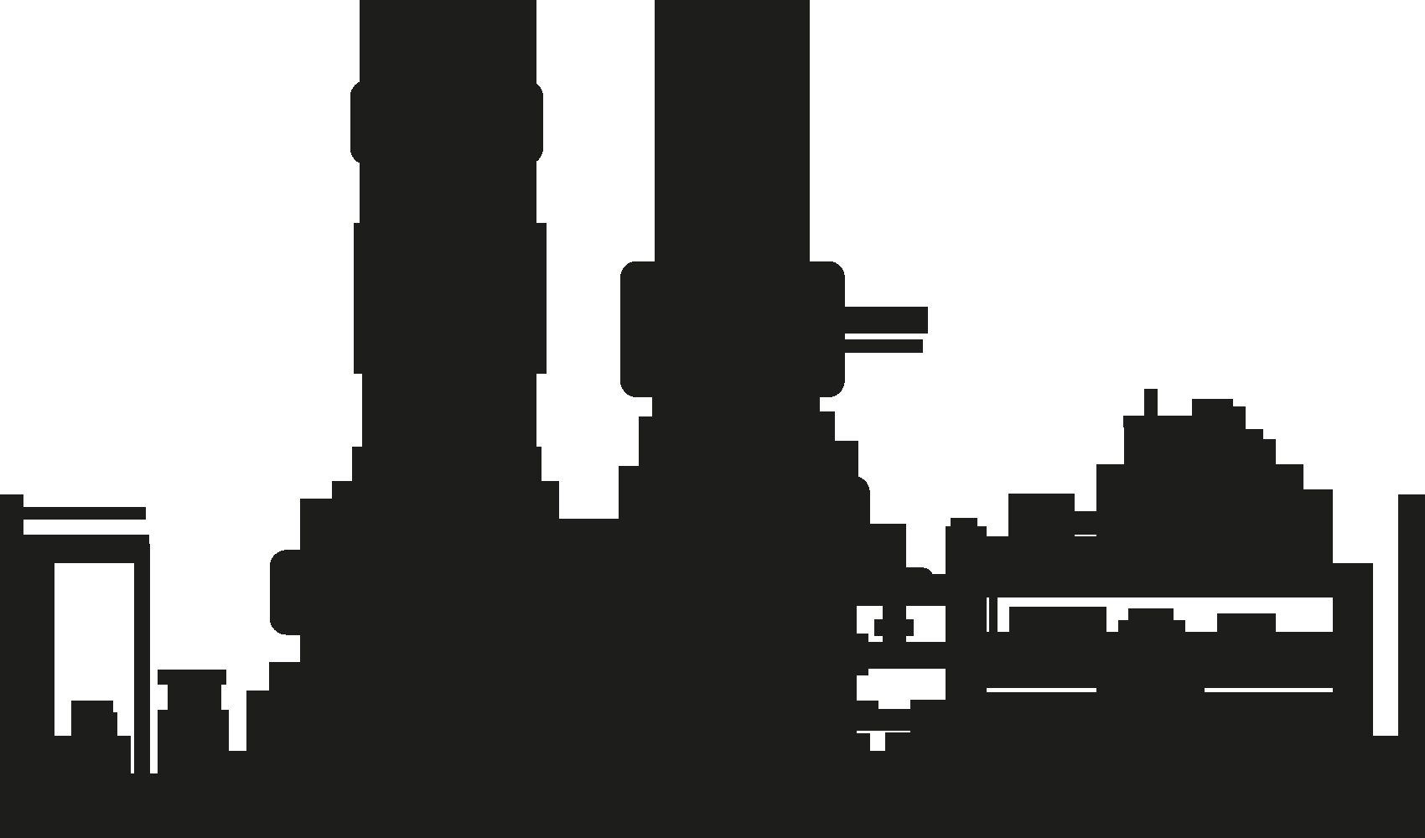

The background images are tileable. This way you can give a nice background movement effect while playing the game.

The final background should look like this:

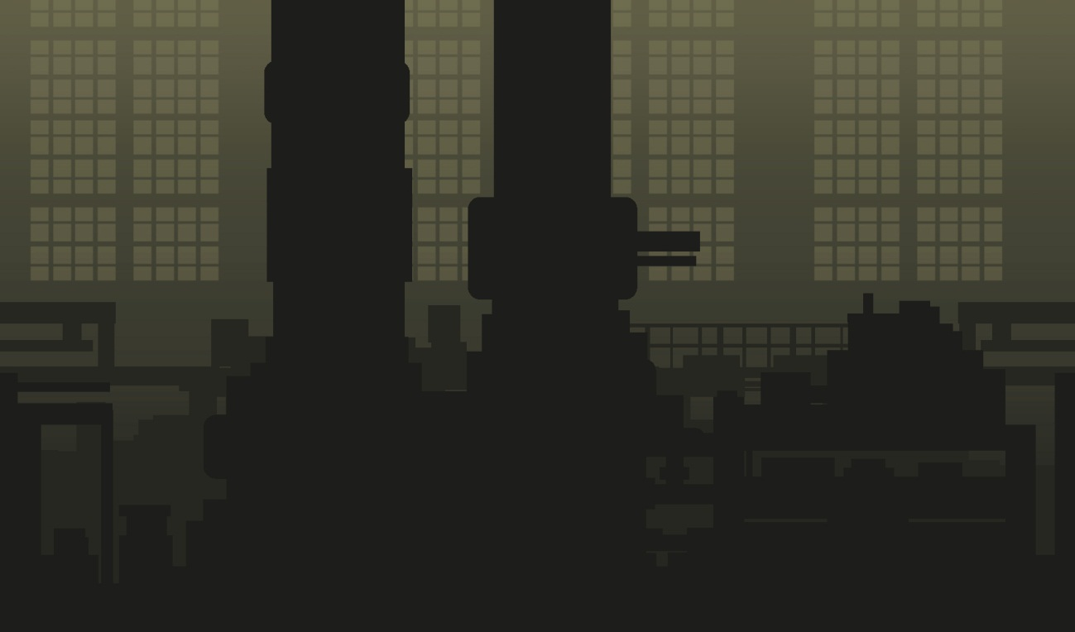

If you want to use just a simple background (without animation) use the JPG files ( folder: Plataform Game Tileset 2_The Factory\JPG)

If you have any doubts about the product just send me an email to [blue_acesky@hotmail.com](mailto:blue_acesky@hotmail.com) and I will be happy to help you.

Have fun! :)

Cristian Alaminos